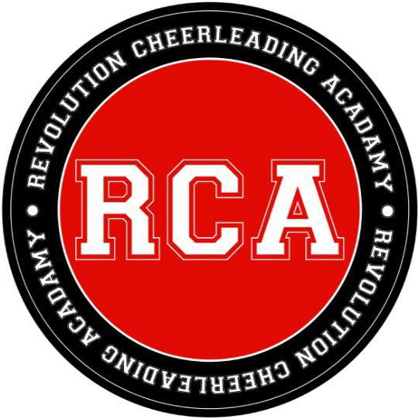

Revolution Cheerleading Academy.
NEW STUDENT REGISTRATION FORM

STUDENT INFORMATION

Student’s Name: ___________________________________ Birth Date: ______________

Age: ________

Address: __________________________________________________________________

Town: ___________________________________ County: __________________________

Postcode: ______________

Home Phone: _____________________________ Mobile phone: ____________________

E-mail: ____________________________________________________________________

EMERGENCY CONTACT

Name: ____________________________________________________________________

Relationship to student: _____________________________________________________

Address: __________________________________________________________________

Town: ______________________________________ County: _______________________

Postcode: ______________

Home Phone: _______________________________ Mobile: _________________________

E-mail: _____________________________________________________________________

Please continue overleaf
CLASS PARTICIPATION: (Classes Participating In)

Class Name Day Time
Please continue overleaf
- ____________________________________________________________________________

- ____________________________________________________________________________

- ____________________________________________________________________________

How did you hear about our studio? ________________________________________________________

If you were referred, who was it by: ___________________________________________________________________________

MEDICAL HISTORY (PLEASE LIST ANY PREVIOUS MEDICAL HISTORY WE SHOULD BE AWARE OF):

___________________________________________________________________________

TUITION
I understand that all fees paid are non-refundable and non-transferable and that tuition shall be paid on arrival to each class, or monthly/termly in advance.

PERSON RESPONSIBLE FOR PAYMENT:

PRINT NAME: _____________________________

SIGNATURE: ________________________________________

DATE: ____________________

RELATIONSHIP TO STUDENT: ______________________________________

WITNESS (Must be at least 18 years of age): __________________________________________________________

RELEASE
Indicated in the space below are any health problems or conditions of which the studio should be aware (such as heart, back, medical, allergy, muscular, pregnancy, diabetes, epilepsy, chemical or neurological condition, special medication, knee/kidney/shoulder problems, etc.). I understand that risk of injury is inherent in any physical activity and I knowingly and voluntarily accept that risk. I, the undersigned, for myself, my heirs, administrators, and executors, hereby waive and release Revolution Cheerleading Academy individually and Revolution Cheerleading Academy and its staff from any and all claims or damages of any kind arising out of my participation in the exercise and/or dance program of Revolution Cheerleading Academy. I certify that I am in proper physical condition to participate in the exercise/dance program and that I have been examined by a licensed physician and found to be in proper physical condition to participate in said program. I, the undersigned, do hereby authorize Revolution Cheerleading Academy and their designated agents (being teachers or administrators employed by Revolution Cheerleading Academy) to obtain medical treatment for myself in emergency situations if needed. This authority includes the power to authorize any and all treatment deemed necessary under the circumstances by a licensed practitioner.
Please continue overleaf

SIGNATURE OF STUDENT: ____________________________________________

Date: _____________
WITNESS (Must be at least 18 years of age): _____________________________________________

EMERGENCY INFORMATION

Name of Dr: _______________________________________________________________________

Address of Dr Surgery: _______________________________________________________________

Allergies to Medications: ____________________________________________________________

Additional Information/Comments:_____________________________________________________

_________________________________________________________________________________

